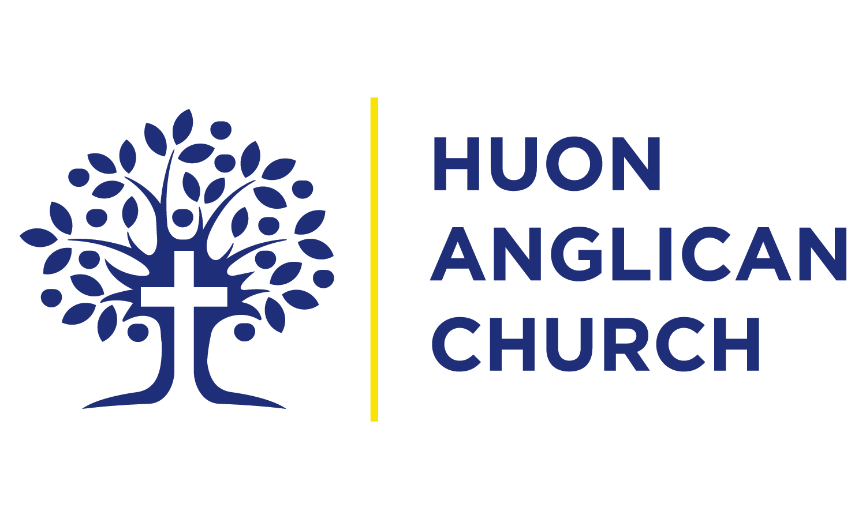
Volunteering at the Huon Anglican Opportunity Shop

Hi there,

Thanks for your interest in volunteering at the Huon Anglican Op Shop.

The shop is a great place to volunteer – you’ll get to meet lots of diverse people and serve the Huon Valley community.

The very first step to volunteering at the Op Shop is to have an informal chat with our Op Shop Manager. If there is a position available, the Manager will have a chat to you about the ways in which you could serve.

Please note that apart from the Manager, the Op Shop is run on an entirely volunteer basis.

We do not hide the fact that we are a church-run Op Shop. We want to bless the community through the provision of cheap or free household goods. Much of the money we raise in the shop goes towards the ministry of the Huon Anglican Church. While many of our volunteers are not Christians, you would need to be comfortable with the fact that it is run and managed by Christians.

Again, thank you for your interest, and we wish you all the best with your application.

HUON ANGLICAN CHURCH OP SHOP VOLUNTEER APPLICATION FORM

FULL NAME:…………………………………………………….APPLICATION DATE: ………………………...

D.O.B:……………………………………………PHONE:……………………………………………………………….

ADDRESS:……………………………………………………………………………………………………………………

EMAIL:………………………………………………………………………………………………………………………..

QUALIFICATIONS:………………………………………………………………………………………………………...…………………………………………………………………………………………………………………………………..

MEDICAL CONDITIONS (alergies,etc):………………………………………………………………………….
………………………................................................................................................................

EMERGENCY CONTACT (NAME/PHONE):……………………………………………………………………

RELATIONSHIP:……………………………………….

DAYS/HOURS AVAILABLE TO VOLUNTEER (PLEASE CIRCLE):

Monday Tuesday Wednesday Thursday Friday

NOTES:……………………………………………………………………………………………………………………………………………………………………………………………………………………………………………………………

I have read the attached pages regarding Safe Church Communities, and have complied with all four requirements.

SIGNATURE:………………………………………….DATE:………………………………….

Please return this page, and the attached paperwork to 21 Wilmot Rd, Huonville 7109.

Huon Anglican Church Op Shop
Safe Church Communities

As a part of the Anglican Church in Tasmania, all those involved in volunteering in the Op Shop are required to comply with a number of requirements. Please note these are not negotiable, and volunteering cannot begin until all four standards are met.

We recognise and accept that not everyone who volunteers at the Op Shop and Mission 21 necessarily holds the same beliefs as those involved in the Church community. However, as the shop is run by the Anglican Parish it acts as a ‘public face’ to the community. As such, we require our volunteers to adhere to certain standards of behaviour.

Volunteers in the Opportunity Shop and Mission 21 are required to comply with these four requirements:

- Have a current Working with Vulnerable People card

We cannot have people working in the Op Shop and Mission 21 without this. Children and vulnerable people are going to be coming into the Op Shop, and you will be interacting with them. Information about how to apply for this is found on the following website:

https://www.cbos.tas.gov.au/topics/licensing-and-registration/registrations/work-with-vulnerable-people

Please note your application for the Op Shop cannot be accepted until you have a valid card.

- Fill out a Safe Church Communities (Voluntary Ministry) Application Form

Once you have applied for and received your Working with Vulnerable People card, you then need to fill out the Safe Church Communities Application Form. Please make sure every box is filled out. It includes the details of two referees who can attest to your character. One of these people must be our minister, Rev John McQuillan. If you require assistance, please ask the Op Shop Manager. It is available from:
https://anglicantas.org.au/safe-church-communities-scc/

- Complete Faithfulness in Service Training

As mentioned above, as the Op Shop acts as a ‘face’ of the Anglican Church in the community, we require volunteers to do Faithfulness in Service training, run by the Anglican Diocese of Tasmania. This short course takes people through the behavioral standards required of those volunteering in church programs. It has a short multiple choice quiz at the end. This can be done in 2 ways:
- Face-to-face training with a short quiz at the end. Please ask us how to do this.
- Do the training online. Please let us know if you wish to do this, and we can set you up on our training system.

- Complete the first two modules of ChildSafe Training.

As children will be coming into the Op Shop, it is imperative that we are trained appropriately in how to make sure they are safe. The Anglican Church in Tasmania utilizes a training program called Childsafe. ChildSafe training can be done in 2 ways:
- Attend a face-to-face training session. Please ask us for the next available training date (takes approx. 1-2hrs).
- Do the training online. Please speak to us if you wish to do this, and we can set you up on our training system.

Thank you for your interest in the work that we do here. We appreciate that the requirements are stringent; it is done in the best interests of protecting vulnerable people to ensure we are a safe place for them to come. If you have any questions, please do not hesitate to ask.

Kind regards,

Rev John McQuillan
Op-Shop Manager Minister, Huon Anglican Church

Please fill out and return to 21 Wilmot Rd, Huonville 7109

Name:_________________________________

Working with Vulnerable People Card Number:________________Expiry:________

I would like to do Faithfulness in Service Training Online
I would like to attend face-to-face Faithfulness in Service training at a time to be negotiated.

I would like to do Childsafe Training online
I would like to attend face-to-face Childsafe training at a time to be negotiated.

I have attached my Safe Church Communities application form

